|  |  |
| --- | --- |
| **Test** | |
| Team I: Spring Validation Demonstration | |
| **Mission Statement** | |
| The Lunar ROADSTER uses the excavator to **groom one crater** in a **simple, straight path** in the Moon Yard. | |
| **Objectives** | |
| Demonstrate the rover’s dozing capabilities in a simplified localization and path planning setting. | |
| **Location** | Planetary Robotics Lab Moon Yard |
| **Equipment** | Lunar ROADSTER rover, Leica TS16 total station, operations terminal (team laptop), NVIDIA TX2 relay chip, LAN router, FARO laser scanner |
| **Subsystems** | Sensors, computations (except validation unit and slope avoidance in navigation unit), external infrastructure, mechanical, actuation & electronics, electrical power |
| **Personnel** | Ankit Aggarwal, Deepam Ameria, Bhaswanth Ayapilla, Simson D’Souza, Boxiang Fu |
| **Procedure** | |
| **Prior Setup:**   1. Prepare the Moon Yard with a suitable crater and dune. 2. Scan the Moon Yard with a FARO Scanner to obtain a global map for navigation. 3. Attach and connect all the components and subsystems of the rover. 4. Set up the external infrastructure such as the total station in the corner of the Moon Yard, the LAN router, and the TX2 relay. 5. Place the rover in the Moon Yard and calibrate its localization using the total station.   **During Demonstration:**   1. Turn on the rover and SSH into the Lunar ROADSTER docker on the operations terminal laptop. 2. Switch the rover to autonomous mode and run the start-up procedure. 3. Observe the rover autonomous grade the crater and level the dune. 4. If anything unexpected occurs press the emergency stop button. | |
| **Validation Criteria** | |
| **M.P.1:** Will plan a path with **cumulative deviation of <= 25%** from chosen latitude’s length (due to untraversable terrain)  **M.P.2:** Will **follow planned path** to a **maximum deviation of 10%** (due to localization/navigation error)  **M.P.4 (Part 1):** Will **avoid craters >= 0.5 meters** (shown in global navigation plan)  **M.P.5:** Will fill craters of **up to 0.5 meters** in diameter and **0.1m in depth** | |
|  | |

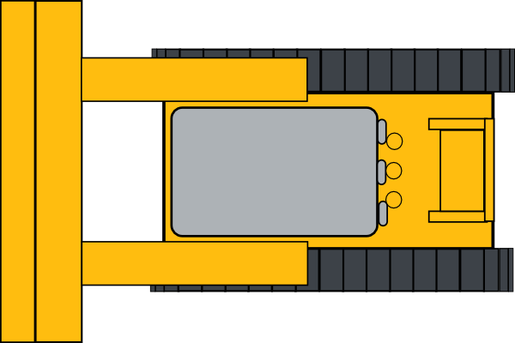

Groom one crater

Follow a straight path